# Git & IntelliJ FAQs - Assignment Task

1. 1. What is the use of the git add command?

The `git add` command stages changes (modified or new files) to be included in the next commit. It tells Git which files you want to track in the upcoming commit.

1. 2. Write the command to create a branch “feature-group”.

git branch feature-group

1. 3. What is a pull request? Write the steps involved in creating a pull request.

A pull request is a way to propose changes in one branch to be merged into another branch on a Git hosting platform like GitHub.  
Steps: Push your branch to GitHub → Go to the repository → Click 'Compare & pull request' → Add description → Click 'Create pull request'.

1. 4. How do you add collaborators?

Go to your repository on GitHub, open the Settings tab, and click Collaborators. Add their GitHub username or email and send an invite.

1. 5. What is the command used to commit our changes in GitHub repo?

git commit -m "commit message"

1. 6. Create a GitHub account and repository to save all your assignment tasks. Example repository name: rg-assignments

Go to https://github.com, sign up, and click 'New Repository'. Name the repository rg-assignments and initialize with a README if needed.

1. 7. Create a branch called feature-java (you can use it later to push all your java related tasks to this branch)

git branch feature-java

1. 8. Install IntelliJ IDE. Create a simple Java project displaying “Hello World!!” and share the screenshot.

Open IntelliJ → New Project → Java → Create Hello World.java file:  
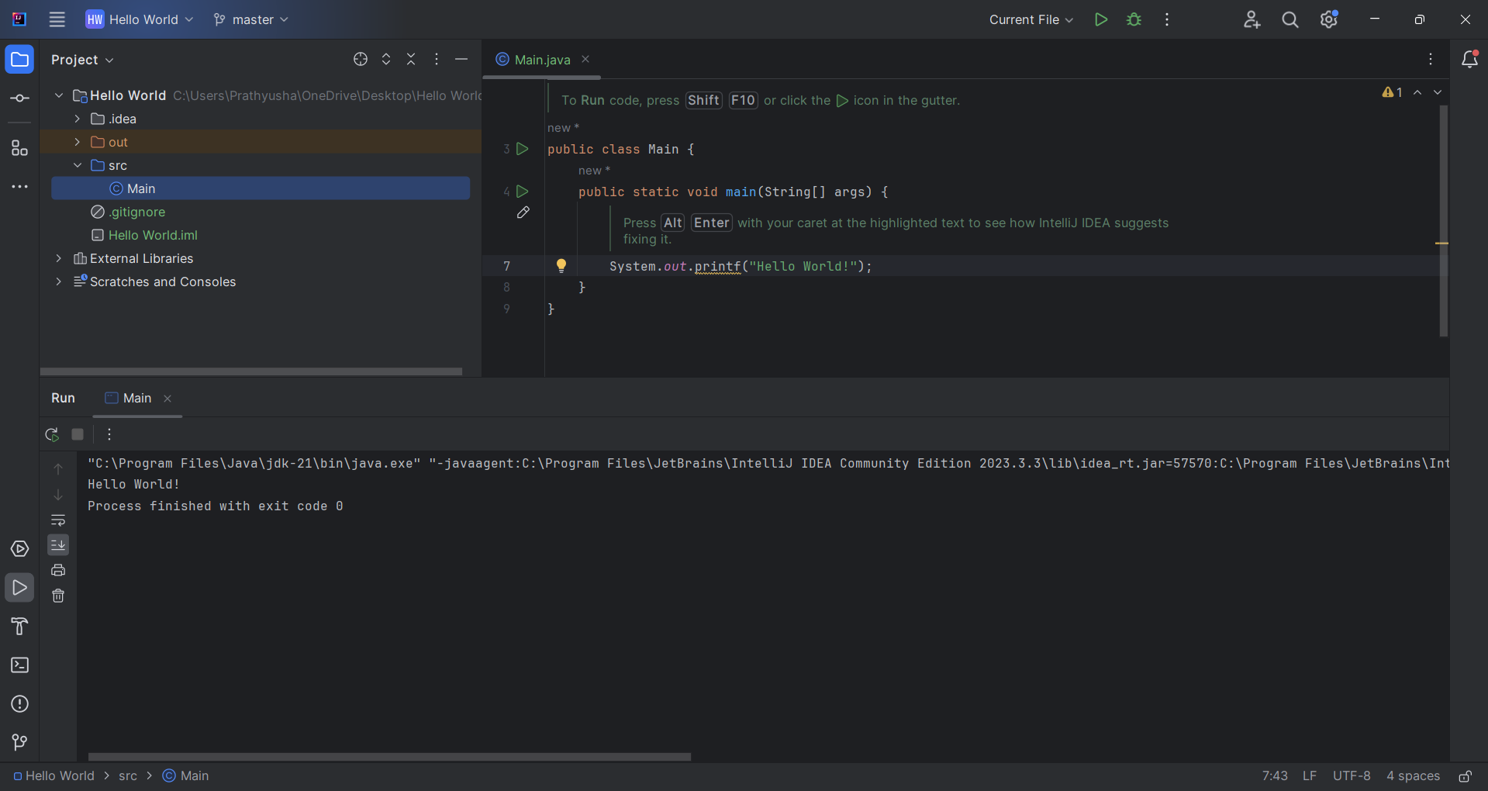

1. 9. In IntelliJ IDE, explore the shortcut keys for the following:

- a. To run the project: Shift + F10  
- b. To select a line: Home, then Shift + End  
- c. To comment/uncomment a line: Ctrl + /  
- d. To delete a line: Ctrl + Y